Referat lucrare de laborator 2 – Constantinescu Vlad 314CB

Exercitiu a)

Exercitiul b)

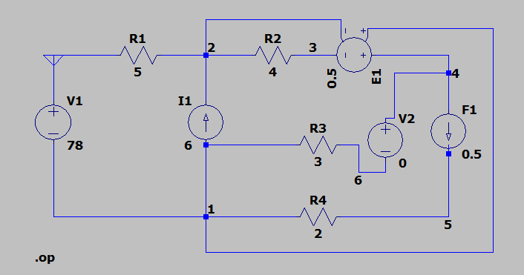

Exercitiul c)

